Dear Catholic Academy Families,
Student Council is very excited to begin working on our school’s annual Thanksgiving Food Drive. This year, we are going to encourage each grade level to bring in specific food items throughout November. This will ensure that we get a variety of foods most needed by our local food pantries. Please refer to the following chart:
Grade Levels | Food Items
Pre-K 3, Pre-K4, K | Week 1 (11/12-11/13) – peanut butter, jelly  Week 2 (11/16-11/20) – cereal, canned fruit  Week 3 (11/24-11/25) – rice, beans, hand sanitizer
Grades 1, 2, 3, 4 | Week 1 (11/12-11/13) – canned vegetables, canned tuna  Week 2 (11/16-11/20) – napkins and cups  Week 3 (11/24-11/25) – pasta and sauce, disposable masks
Grades 5, 6, 7, 8 | Week 1 (11/12-11/13) – applesauce, mac n’ cheese  Week 2 (11/16-11/20) – crackers, canned soup  Week 3 (11/24-11/25) – plates, silverware, disinfectant wipes
*Please feel free to donate any other non-perishable food items not on the list.
*Given this year’s circumstances, we’ve added a few items that food drives might also need to combat the spread of COVID-19. We understand that these items may not be available and are hard to find. We appreciate your efforts!

Once the items start to come in, members of our Student Council will organize and display them on our gym stage. On the day of our Thanksgiving celebration, it will be so rewarding to see how our school has come together to help those in need. Every donation is very much appreciated. 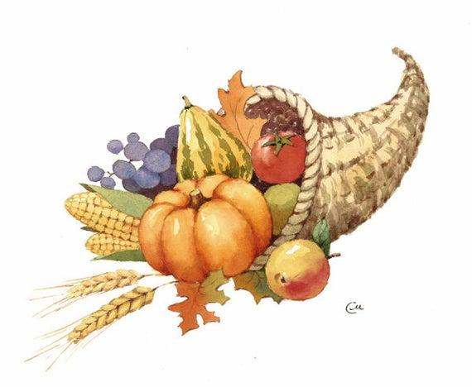 Thank you in advance,
Catholic Academy Student Council

