BASKETBALL CALENDAR 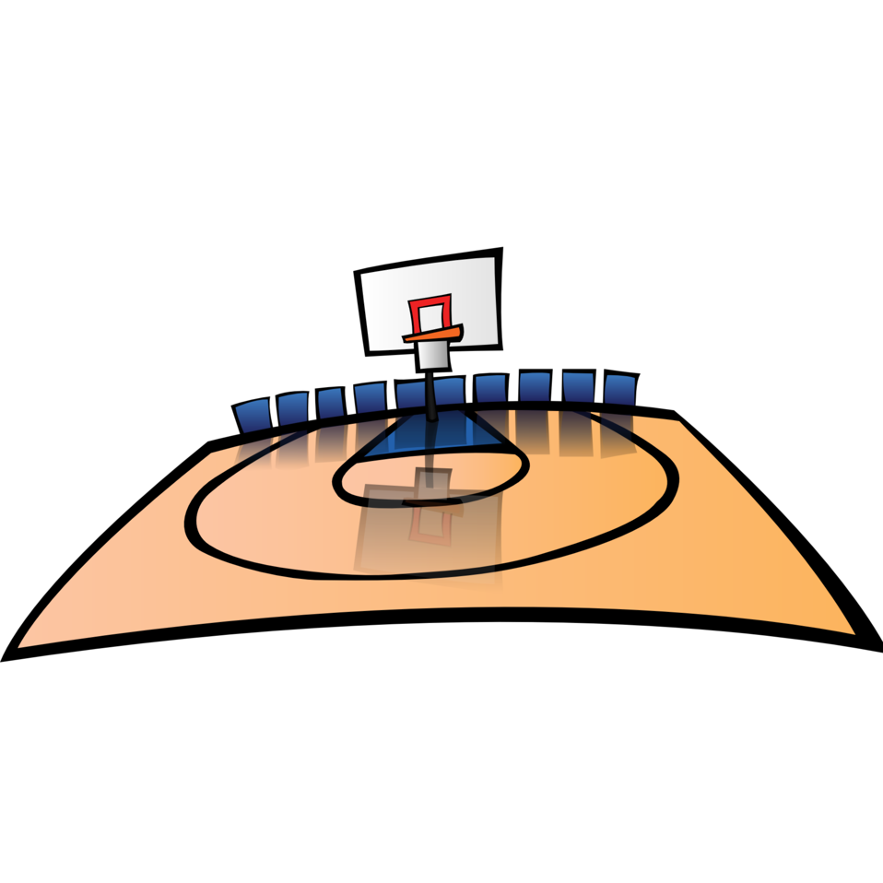

January

10  Varsity Girls 2:30 - 4:00  JV Girls  4:00 - 5:30 | 11  JV Cheer  2:30 - 3:45  JV Boys  4:30 - 6:00 | 12  Varsity Girls 2:30 - 4:00  JV Girls  4:00 - 5:30  JV Boys  6:00 - 7:30 | 13  Varsity Cheer  2:30 - 3:30  Varsity Boys  6:00 - 7:30 | 14  NO GAMES  BYE WEEK
17  NO SCHOOL  NO PRACTICES | 18  JV Cheer  2:30 - 3:45  JV Boys  4:30 - 6:00 | 19  NO Varsity or JV Girls practices  JV Boys  6:00 - 7:30 | 20  Varsity Cheer  2:30 - 3:30  JV Girls  4:00 - 5:30  Varsity Boys  6:00 - 7:30 | 21  Catholic Academy AT Holy Ghost (St. James Gym 2437 Niagara Rd.)  3:45 JV Boys  5:00 Varsity Boys  6:15 Varsity Girls  7:30 JV Girls
24  Varsity Girls 2:30 - 4:00  JV Girls  4:00 - 5:30  Varsity Boys  6:00 - 7:30 | 25  JV Cheer  2:30 - 3:45  JV Boys  4:30 - 6:00 | 26  Varsity Girls 2:30 - 4:00  JV Girls  4:00 - 5:30  JV Boys  6:00 - 7:30 | 27  Varsity Cheer  2:30 - 3:30  Varsity Boys  6:00 - 7:30 | 28  St. John AT Catholic Academy  3:45 JV Boys  5:00 Varsity Boys  6:15 Varsity Girls  7:30 JV Girls

